**AOOP PROJECT-ATM INTERFACE**

**1. Launch Application: Initial Login or Signup**

* When the ATM application is launched, a **Login Page** is displayed.
* If the user already has an account, they can enter their **Account Number** and **PIN** to log in.
* If the user does not have an account, they should click on the **Sign Up** button to create one.

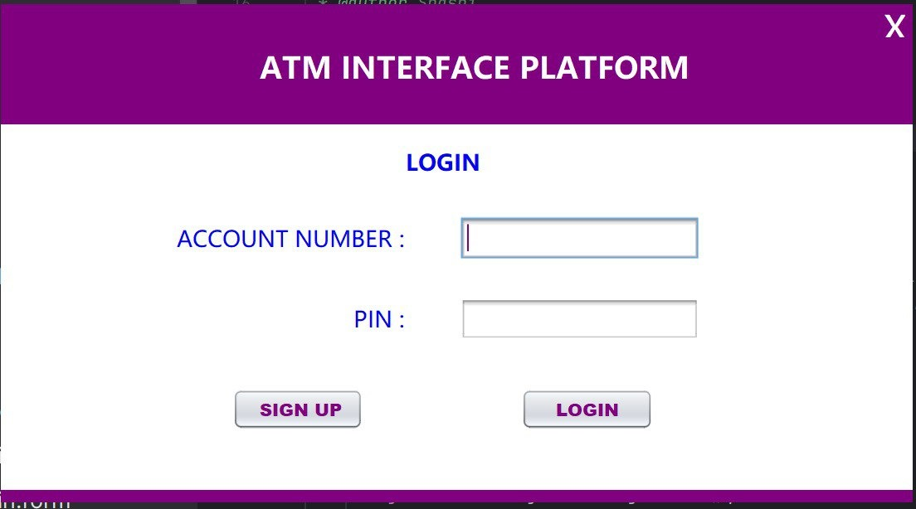

**2. Creating an Account (Sign-Up Process)**

* Upon selecting **Sign Up**, a **Sign-Up Form** appears.
* The user must fill out required details, which typically include:
  + Name
  + Phone number (validated to accept only 10-digit entries)
  + Desired PIN
* After completing the form, the user submits their details.
* The user can now proceed to the login process with this account information.

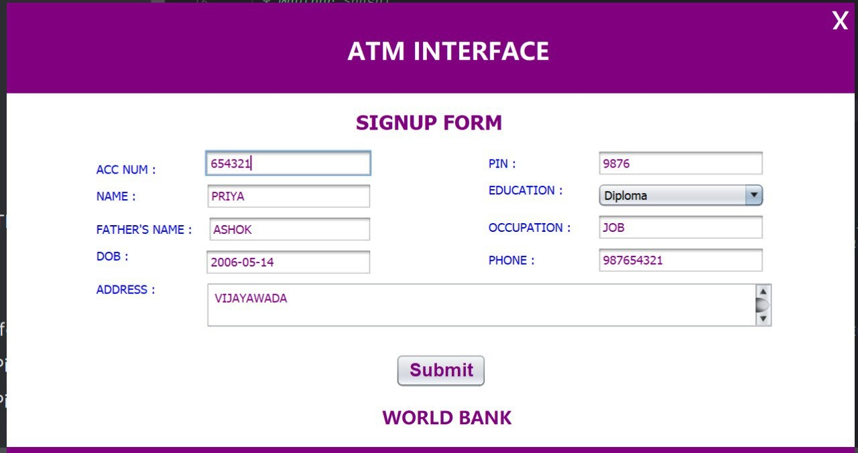

* A confirmation message, "**Details Saved**," is shown.

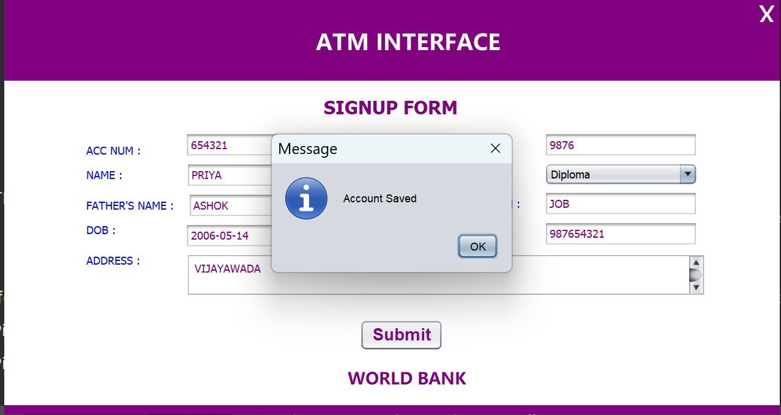

* The user is then provided with a message which displays their account number and the pin they set for it.

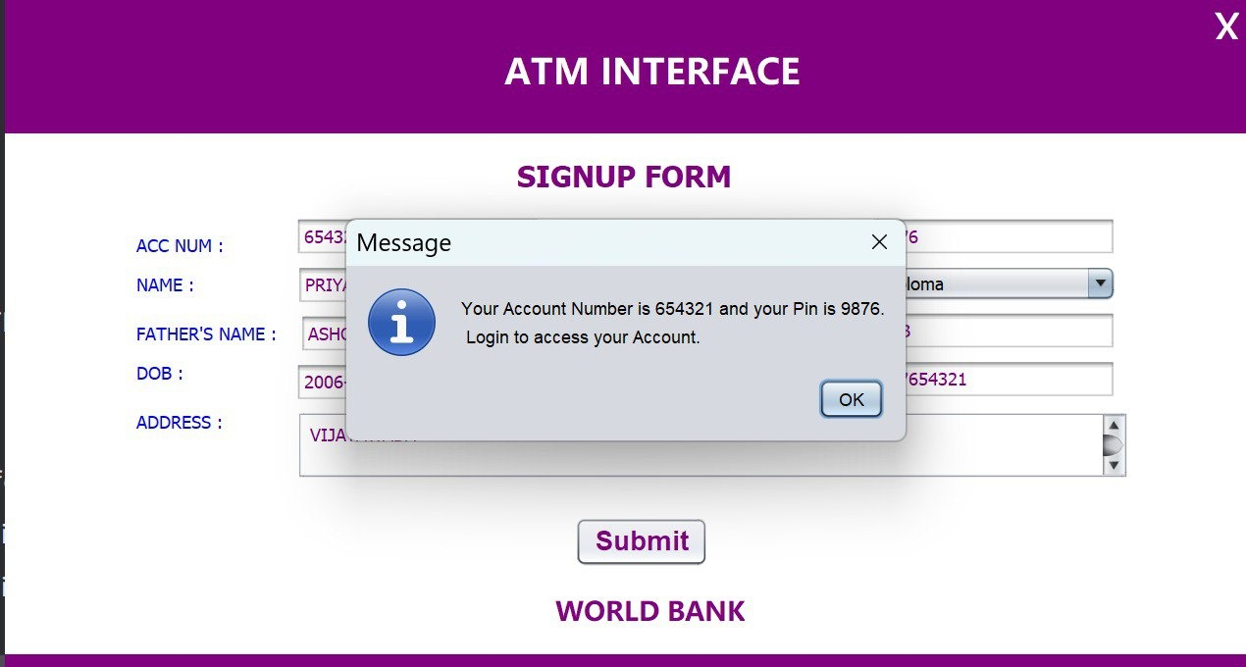

**3. Logging into the Account**

* The user returns to the **Login Page**.
* They enter their **Account Number** and **PIN** to log in.
* Upon successful login, the **Main Menu** is displayed, presenting various options.

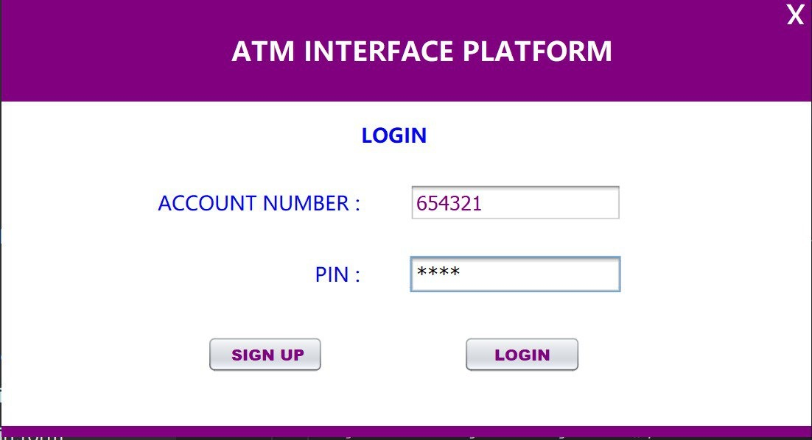

**4. Main Menu Options**

* The Main Menu offers several functionalities:
  + **Deposit**
  + **Withdraw**
  + **Check Balance**
  + **View Mini Statement**
  + **Change PIN**

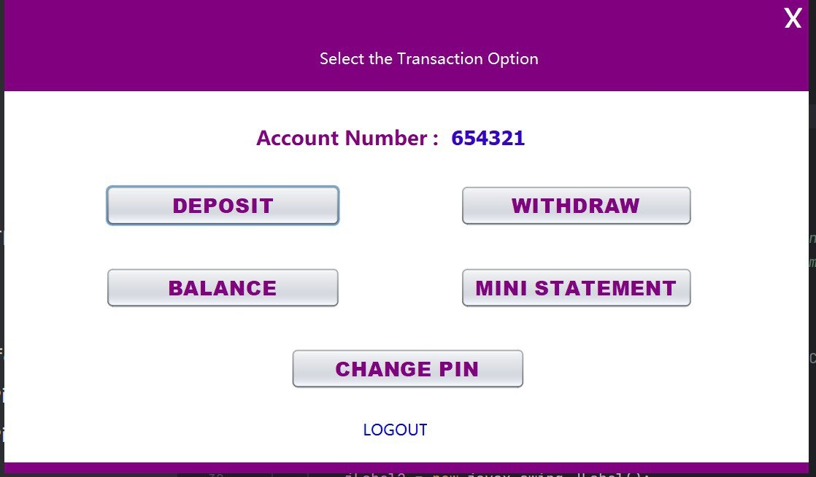

**5. Making a Deposit**

* To deposit money, the user selects **Deposit** from the Main Menu.
* The user enters the **amount** they wish to deposit.

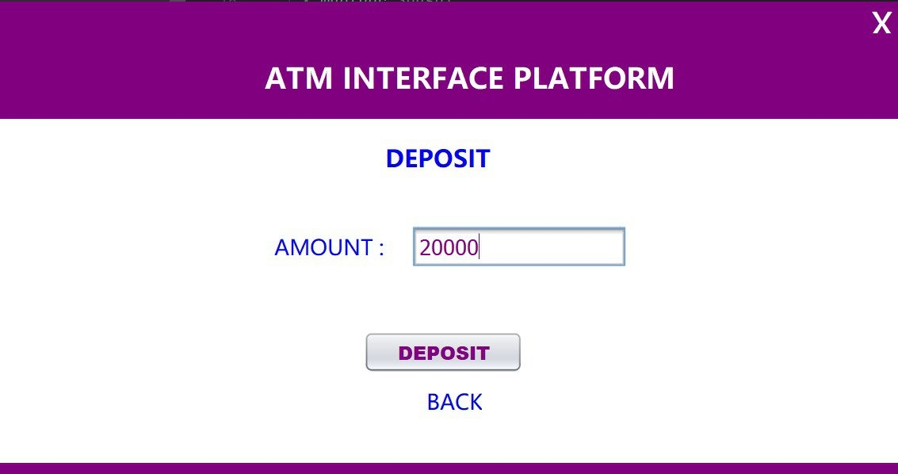

* After submitting the amount, a message confirms that the **balance has been updated**.

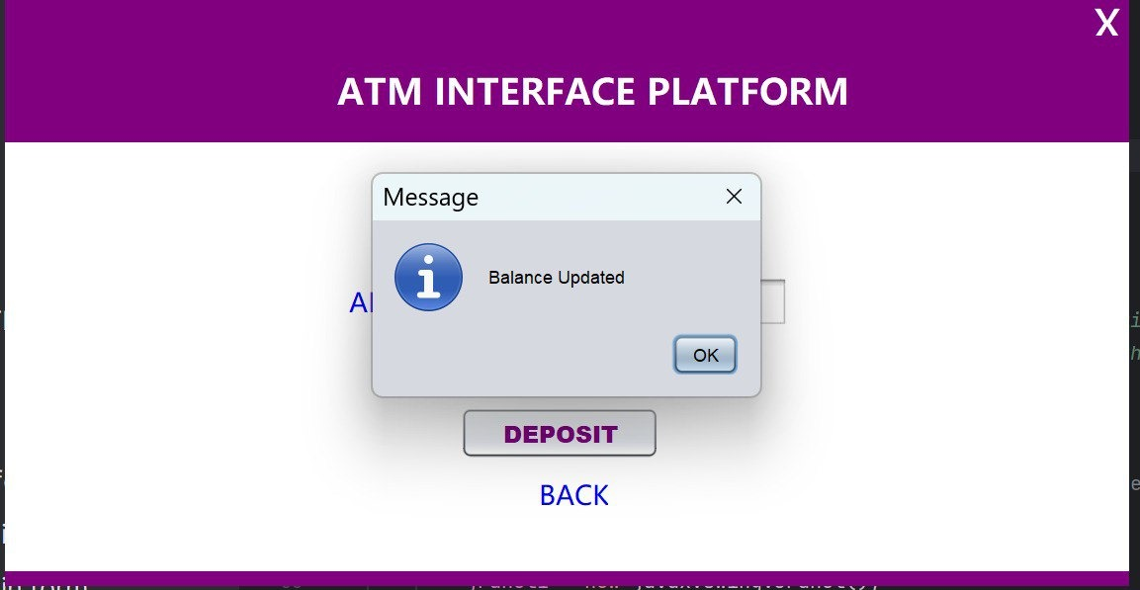

**6. Withdrawing Money**

* To withdraw money, the user selects **Withdraw** from the Main Menu.
* The user specifies the **amount** they want to withdraw.

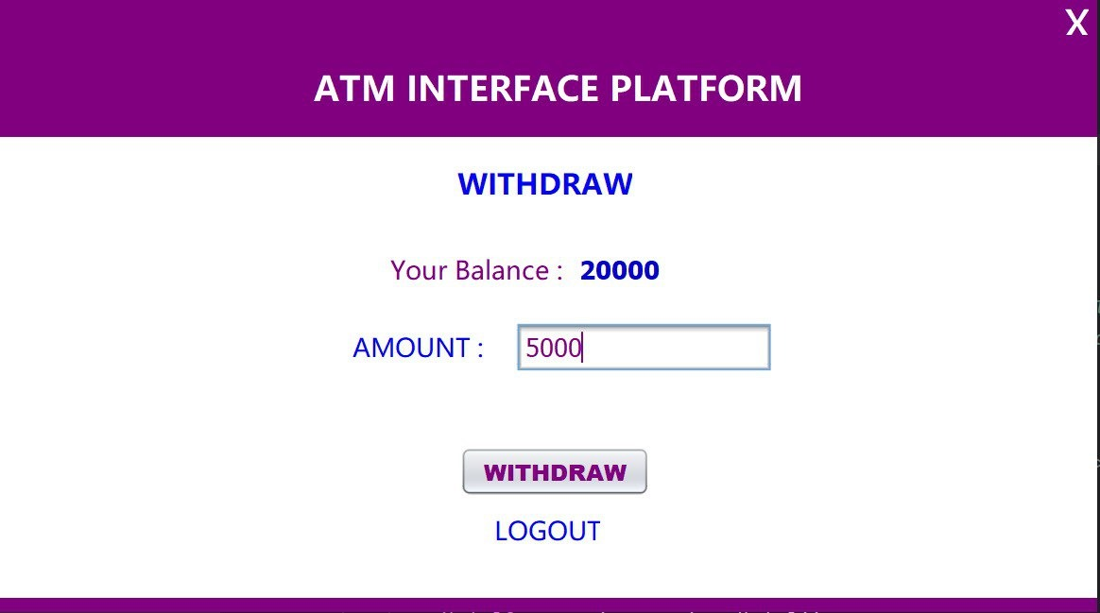

* After submitting the request, a confirmation message, "**Withdraw Successful**," is shown.

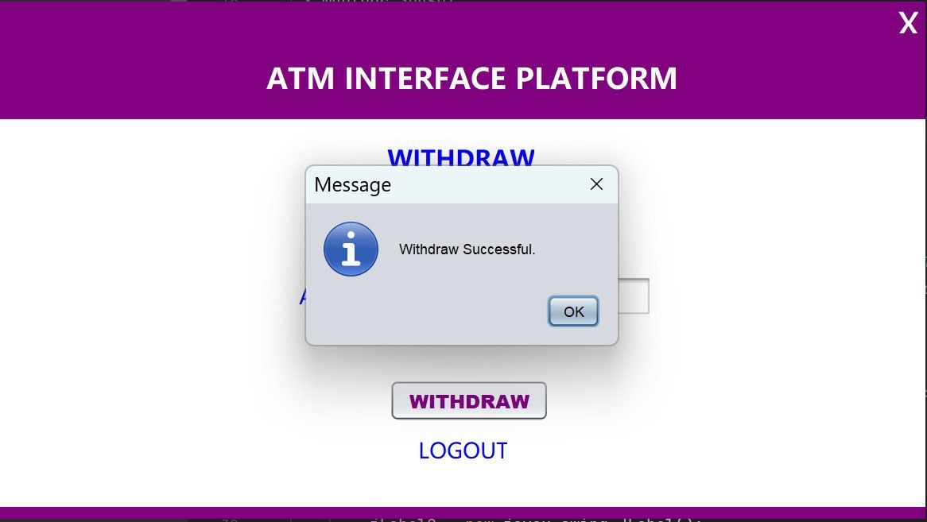

**7. Checking Account Balance**

* The user selects **Balance** from the Main Menu.
* The application displays the **current account balance**.

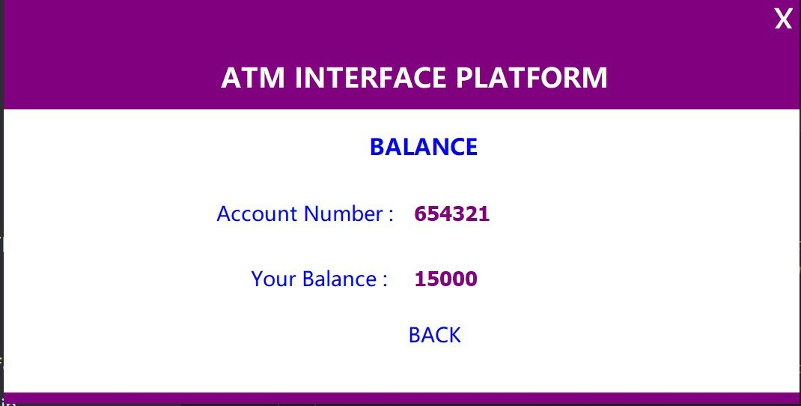

**8. Viewing Mini Statement**

* To view recent transactions, the user selects **Mini Statement**.
* The Mini Statement displays the **transaction history** for deposits and withdrawals.

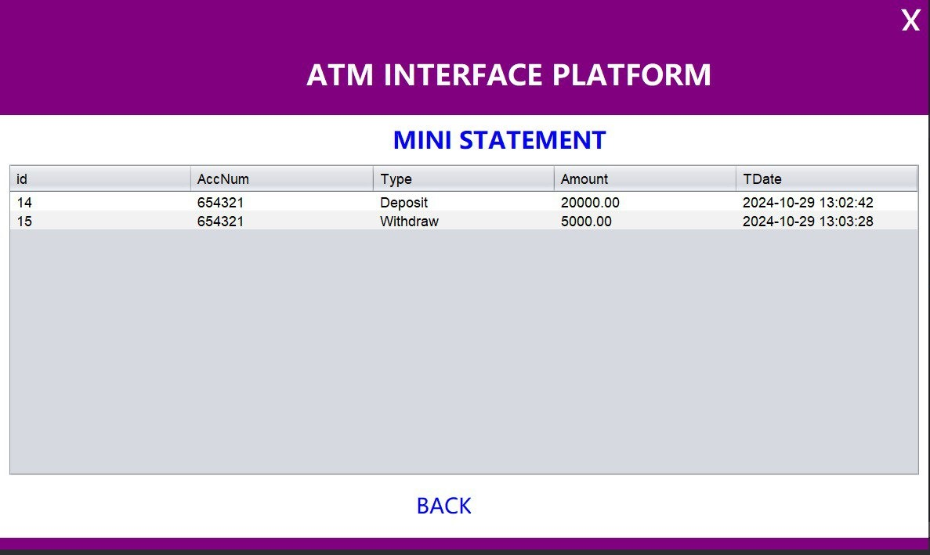

**9. Changing the PIN**

* To change the account PIN, the user selects **Change PIN**.
* The user enters a **new PIN** and confirms it by re-entering it in the **Confirm PIN** field.

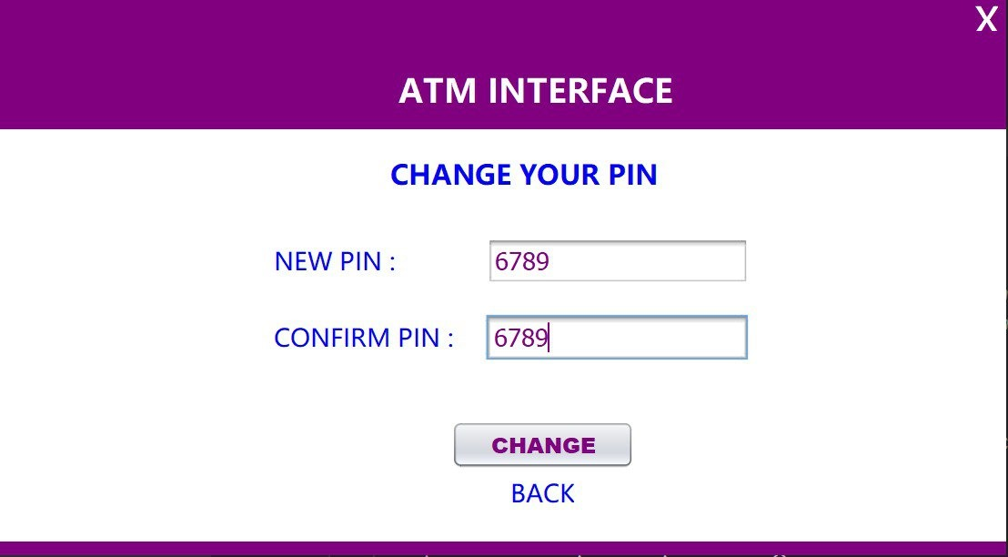

* After submitting, a confirmation message, "**PIN Updated Successfully**," appears.

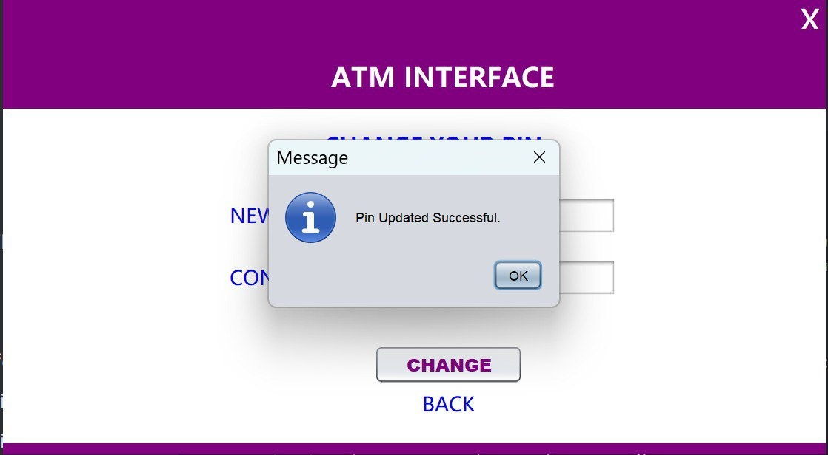

**1. Account Information Storage: “accounttbl”**

The “accounttbl” is the primary table for storing all essential account-related details provided during the Sign-Up process. Each account entry includes a unique **Account Number** to identify each user securely. The table also holds:

* **Account Name**: The full name of the account holder, used for verification and reference.
* **Father's Name**: Additional personal detail that may be used for identity verification.
* **Phone Number**: A 10-digit contact number for account-related communication and validation.
* **Date of Birth**: The birth date of the account holder, adding to the user’s identification profile.
* **Address**: The residential address provided by the user.
* **Education and Occupation**: Details about the account holder’s educational background and employment.
* **Balance**: Reflects the current balance in the account, which updates with each deposit or withdrawal.
* **PIN**: A secure, user-defined personal identification number required for login and transaction access.

This structure in “accounttbl” allows the application to store comprehensive profile information securely, ensuring ease in account management and verification.

**Account Information Storage: “accounttbl”**

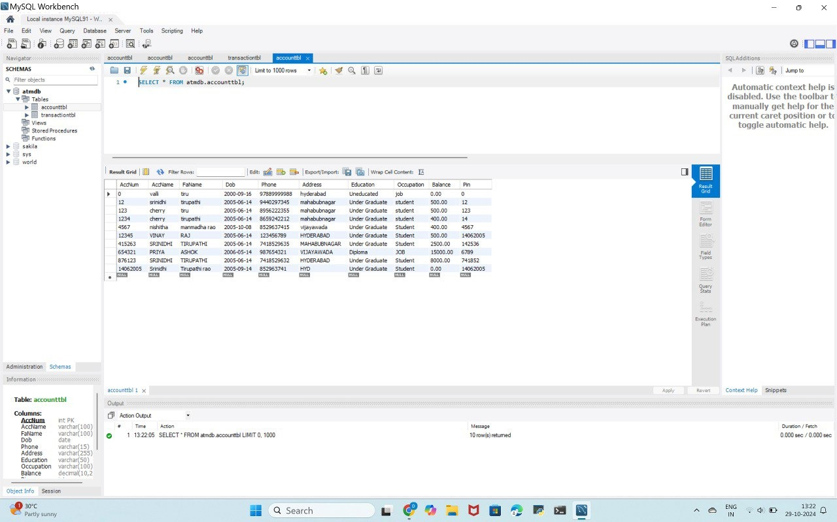

**2. Transaction Information Storage: “transactiontbl”**

The “transactiontbl” is dedicated to recording each financial transaction conducted by users, such as deposits and withdrawals. This table includes:

* **Account Number**: A foreign key linked to the accounttbl, associating each transaction with a specific account.
* **Transaction Type**: Specifies the type of transaction, such as "Deposit" or "Withdrawal," for clear differentiation.
* **Amount**: The amount involved in the transaction, indicating funds added or withdrawn.
* **Transaction Date**: The date on which the transaction took place, providing a timeline of account activity.

By maintaining these details in transactiontbl, the application can efficiently track and manage transaction histories, providing users with a clear and accurate account of their financial activities.

